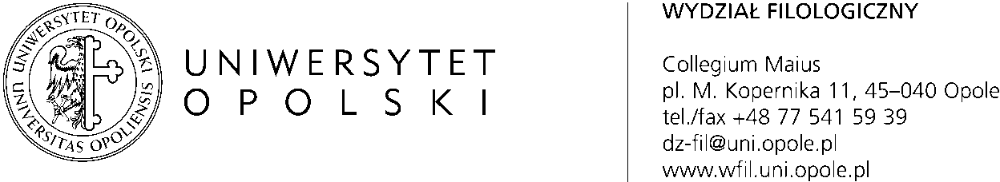

STUDENT REPORT ON
THE PSYCHOLOGICAL-PEDAGOGICAL INTERNSHIP
COORDINATED BY A SCHOOL PEDAGOGUE

(Attention! The internship report in an electronic version is completed by the student-teacher trainee)

Student’s name and surname:

Student ID number:
Study Programme: | English Philology - Teacher Training Programme  Full time/Part time  Faculty of Philology, University of Opole, Poland
Year of study: 1 | semester: 1
Name and surname of supervisor
the pedagogue:
Place of the internship
name of the institution/school
address:
Number of hours | ……./ 15

I HAVE CARRIED OUT THE FOLLOWING TASKS, ACTIVITIES
(a short description of the tasks performed as part of the internship):
1
2
3
4
5
6
7
8
9
10
FORM OF PASSING THE INTERNSHIP

Characteristics of the place of the internship
Classes carried out in the place of the internship
Documentation in the place of the internship (basic and additional)
Characteristics of the group (children / adolescents) attending the place of the internship
Institutions cooperating with the place of the internship

Self assessment of the internship:
Please present your own assessment of the internship and its usefulness in the context of your studies, using the criteria listed below on a scale from 1 (very low) to 5 (very high).
no. | Assessment criterion | Evaluation scale
 |  | very low | low | medium | high | very high
 |  | 1 | 2 | 3 | 4 | 5
 | Being informed about the principles of the internship
 | Supervision by the supervisor
 | Access to information at the place of the internship
 | Opportunity to participate in activities/work at the place
 | Possibility to use the knowledge gained during the internship
 | Usefulness of the internship for the preparation of the MA thesis
 | The prospect of further employment at the place of the internship

Attached to this report, I present the opinion of the internship supervisor – the pedagogue.

(place and date) (legible signature of the student-teacher trainee)

